**DAILY ONLINE ACTIVITIES SUMMARY**

|  |  |  |  |  |  |  |  |  |
| --- | --- | --- | --- | --- | --- | --- | --- | --- |
| **Date:** | **08/07/2020** | | | | | **Name:** | **NIKHIL KUMAR** | |
| **Sem & Sec** | **4thSEM. & ‘B’ SEC.** | | | | | **USN:** | **4AL19CS400** | |
| **Online Test Summary** | | | | | | | | |
| **Subject** | | **DESIGN AND ANALYSIS OF ALGORITHM** | | | | | | |
| **Max. Marks** | |  | | **Score** | | |  | |
| **Certification Course Summary** | | | | | | | | |
| **Course** | Front-End Web UI Frameworks and Tools: Bootstrap 4 | | | | | | | |
| **Certificate Provider** | | | **Coursera** | | **Duration** | | | **4week** |
| **Coding Challenges** | | | | | | | | |
| **Problem Statement1: -**Write a java program to find whether the given strings are anagram.  Given two strings a and b consisting of lowercase characters. The task is to check whether two given strings are anagram of each other or not. An anagram of a string is another string that contains same characters, only the order of characters can be different. For example, “act” and “tac” are anagram of each other.  **Example:** Input: alvasinsitute aalvsiittnsue allergy allergic  **Output:** YES NO  Explanation: Testcase 1: Both the string have same characters with same frequency. So, both are anagrams. Testcase 2: Characters in both the strings are not same, so they are not anagrams. | | | | | | | | |
| **Status: ---executed** | | | | | | | | |
| **Uploaded the report in Github** | | | | | **Yes** | | | |
| **If yes Repository name** | | | | | <https://github.com/Nikhil401/java-coding/blob/master/Anagram1.java> | | | |
| **Uploaded the report in slack** | | | | | **Yes** | | | |

**Online Test Summary : Subject Design and analysis of algorithm test Descriptive was conducted from module:1 there were 3 question and time assigned from 10:15 to 11:00 am.**

**Certification Course Summary: Today I have spend some times on setting up development environment: Git and Node…..**

**Snapshot is given below** 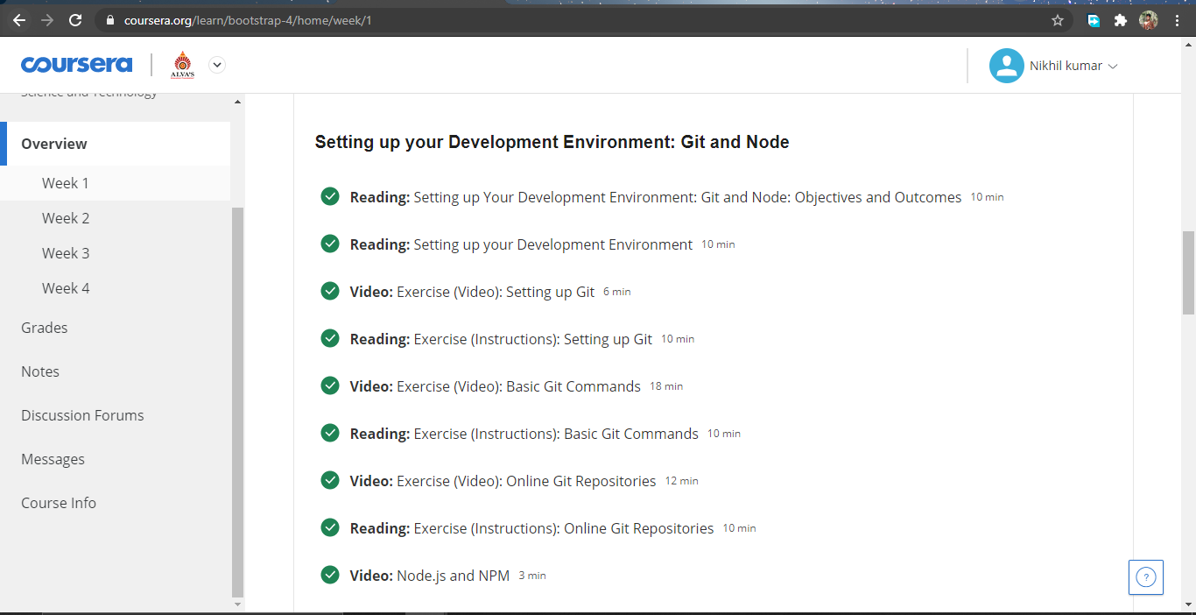

**Online coding summary: Today I had received programs which is mentioned in table above and I have uploaded into the github repository. Snapshot of the program is given below:**

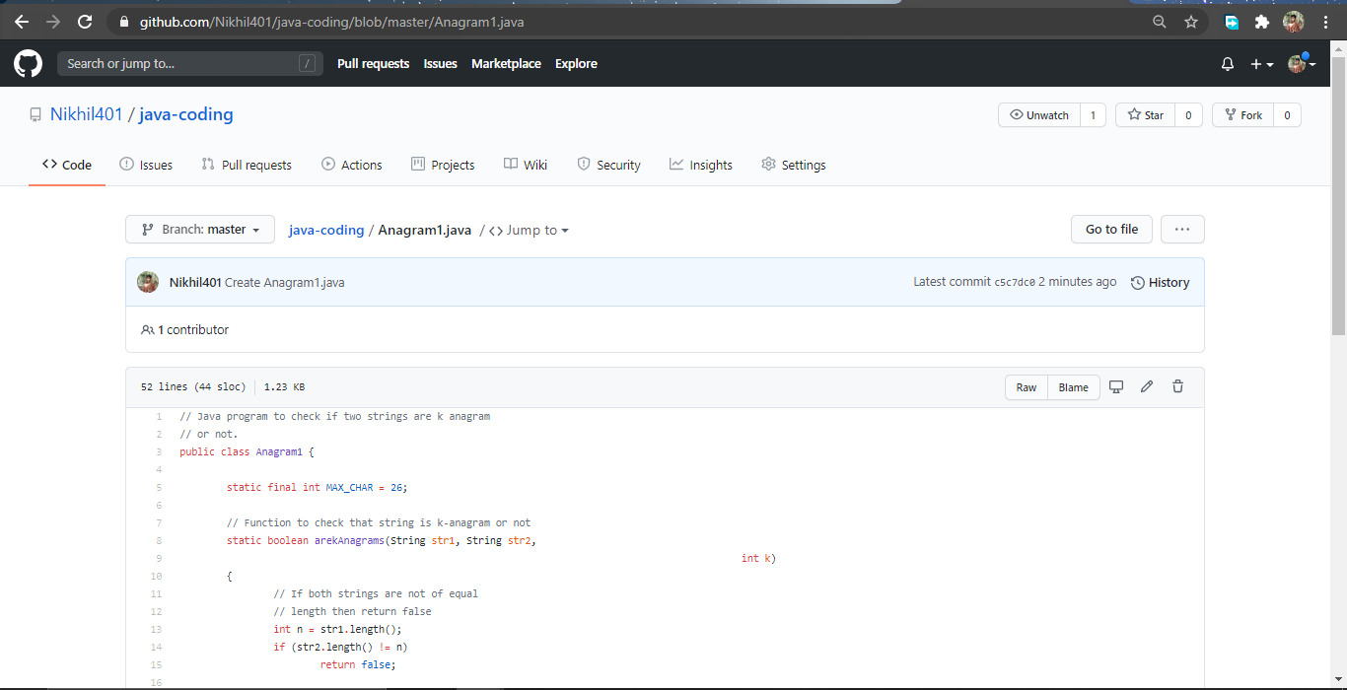**Thank you.**